Organic Chem Concept check  
1.1

1) List the steps of IUPAC nomenclature:

1. Identify parent chain with the highest order functional group
2. Number the chain, give substituents the lowest number
3. Name substituents
4. Assign a number to each substituent
5. Complete name

2) Circle or highlight the parent chain in each of the following compounds:

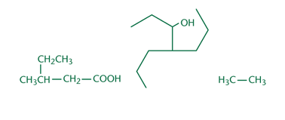

3) Circle and name the substituents in the following molecule, then name the molecule.

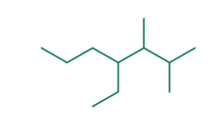

4 ethyl-2-3 dimethyheptane

1.2

1) Fill in the correct names for the alkanes listed below. Ifmore than one compound can be described with a givenmolecular formula, name the straight-chain alkane towhich the formula refers and draw one alternative.

|  |  |  |
| --- | --- | --- |
| Molecular formula | IUPAC name | Alternative structure |
| CH4 | Methyl |  |
| C2H6 | Ethyl |  |
| C3H8 | Propane |  |
| C4H10 | Butane |  |
| C5H12 | Pentane |  |
| C6H14 | Hexane |  |
| C7H16 | Heptane |  |
| C8H18 | Octane |  |
| C9H20 | Nonane |  |
| C10H22 | Decane |  |

2) In a molecule with two double bonds adjacent to each other and an alcohol, which functional group would take precedence in naming?

Alcohol since it is the most oxidized

3) Is the following compound a geminal diol or a vicinal diol?

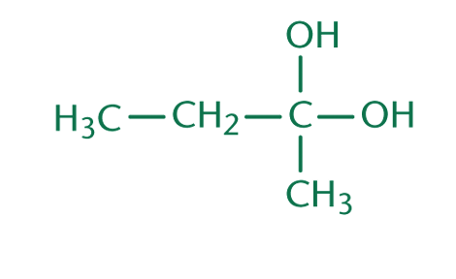

Geminal diol

4) What are the common names for 2-propanol and ethanol?

2-Propanol: isopropyl alcohol

Ethanol: ethyl alcohol

1.3

1) What is the difference between an aldehyde and a ketone?

Aldehyde is terminal and chain ending. Ketone must be in the middle of a carbon chain.

2) What suffixes are used for aldehydes and ketones; how are carbonyl groups named as a substituent?

Ketone = oxo

Aldehyde = al

3) Fill in the common names in the following chart.

|  |  |
| --- | --- |
| IUPAC name | Common name |
| Methanal | Formaldehyde |
| Ethanal | Acetaldehyde |
| Propanal | Propionaldehyde |
| propanone | Acetone |

4) For a molecule with a double bond, an aldehyde, and an alcohol, which functional group would determine the suffix when naming?

aldehyde = first place  
alcohol = second place  
double bond = third place